**Knowledge, Practices, and Family Support Regarding Health-Seeking Behavior Among Breast Cancer Patients in Bangladesh**

Introduction:

Methods:

We followed the STROBE guideline for better observational cross-sectional study reporting in epidemiology.

Study sites and study design:

A multi-center retrospective cross-sectional study was conducted in two primary cancer care facilities located in Dhaka the capital of Bangladesh.

Data collection:

Due to the lack of patient registries, a convenience sampling methodology will be used. Patients visiting these facilities were potential participants in the study. If they meet study inclusion-exclusion criteria, they are requested to participate in the study. Verbal informed consent was taken before collecting data as per study protocol.

Eligibility criteria

In this study, we will survey women aged ≥18 years with suspected breast cancer and patients diagnosed with breast cancer referred to our participating centers. These patients will only be included in the study if their initial stage is documented in the medical records or if their initial stage is unavailable but the initial diagnosis is made no more than 6 months before staging at our facilities. Face-to-face interviews with a structured questionnaire will be conducted by previously trained interviewers who are not involved in the clinical management of the patients.

Outcome variables:

The study assessed the knowledge and practice of participants towards risk factors and health-seeking behavior of breast cancer. Patients' knowledge and practice regarding risk factors were calculated out of the total knowledge-specific and practice-specific questions. Each accurate response gets one point and zeroes for the incorrect one based on the respondent's response. Finally, the respondents who scored greater than or equal to the mean score were considered to have 'good knowledge', and respondents who scored less than the mean score were considered to have 'poor knowledge'. There were 6 knowledge and practice assessment questions with a reliability coefficient above 70% respectively which was calculated using Cronbach’s alpha (https://www.ncbi.nlm.nih.gov/pmc/articles/PMC4205511/).

Possible factors

To find out potential risk factors associated with various types of delays, we examined a range of socioeconomic factors and the medical history of the patients as independent variables. These included the patient's age, geographic location (division), residency (urban or rural), educational attainment (illiterate, primary, and secondary) of both the patient and their spouse, household monthly income, access to portable electronic devices, exposure to mass media, lump breast pain, nipple discharge, skin changes, bone pain, breast self-examination, family history of breast cancer, diagnostic delay, and health-seeking behavior. Diagnosis delay encompasses the period from the patient's first symptom recognition to the commencement of definitive treatment, incorporating both patient and provider delays (https://bmjopen.bmj.com/content/9/9/e030169). In this study, a diagnostic delay is typically regarded as exceeding sixteen (16) weeks.

Statistical analysis

We conducted descriptive statistics by crosstabs, presenting counts and percentages to summarise categorical variables. Chi-square tests and Fisher's exact test were employed to investigate factors associated with different types of delays. Binary and multivariable logistic regression was utilised to identify associated risk factors. Initially, bivariable analysis assessed the relationship between delays and other factors. Univariable (unadjusted) and multivariable (adjusted) logistic regression analyses were then conducted to compare associated risk factors. In the univariable analysis, variables were individually added to the logistic regression model, while in the adjusted model, all possible variables were included simultaneously. In this study, three models were utilised to identify associated risk factors of patient delay, provider delay, and total diagnosis delay, designated as Model 1, Model 2, and Model 3, respectively. Results were reported as unadjusted/crude odds ratios (COR) and adjusted odds ratios (AOR) with their respective 95% confidence intervals and 5% level of significance. All analyses were performed using R software.

Variable selection

Variables were chosen through a two-stage process. Initially, bivariable analysis (chi-square test) was performed individually for each independent variable. A significance threshold of p-value ≤ 0.20 was applied arbitrarily to determine the inclusion of covariates in the multivariable models (https://journals.plos.org/plosone/article?id=10.1371/journal.pone.0242864). In the second stage, a comprehensive multivariable model was constructed using the selected predictor variables. Additionally, we assessed multicollinearity in the final model using a cut-off value of 4.00 for the variance inflation factor (VIF) analysis (https://link.springer.com/article/10.1186/s12889-023-15617-8). At this stage, all variables were incorporated into the model since the VIF values for each variable were below 4.00.

Model performance

We utilised the Area under the Receiver Operating Characteristic (AUROC) curve, sensitivity, specificity, and the Hosmer–Lemeshow goodness-of-fit test to assess the accuracy of the best model. Higher AUROC values indicated superior model performance. In the ROC curve, a lower p-value suggests that the model effectively discriminates between two categories, with an area under the curve exceeding 0.50 (https://link.springer.com/article/10.1186/s12981-022-00495-8). The Hosmer–Lemeshow goodness-of-fit test evaluates the similarity between model-estimated probabilities and observed outcomes, typically through a goodness-of-fit test. A Hosmer–Lemeshow goodness-of-fit test with a p-value greater than 0.05 indicates the model's ability to accurately classify observations into outcome categories (<https://www.frontiersin.org/journals/public-health/articles/10.3389/fpubh.2022.985445/full>).

Results

Study population

Out of the 355 study participants, the largest proportion, 34.98%, were aged between 40 and 49 years. The highest concentration, 43.95%, resided in the Dhaka division, and a significant majority, 72.75%, hailed from rural areas, representing the largest demographic in this study. Regarding marital status, a substantial 82.75% of participants were married. Illiteracy was prevalent among a significant number of patients, comprising 42.86%, while the primary education level was predominant among spouses, accounting for 37.11%. Additionally, more than a third of participants reported a monthly family income of <5,000 BDT, marking the highest figure in this study. Access to portable electronic devices, such as mobile phones, smartphones, and computers, was nearly common among patients, with 89.86%. Moreover, 59.44% of participants hadn’t access to mass media (Table 1).

The medical history of the patients is presented in Table 2. A majority (88.45%) of patients reported lump symptoms as their initial clinical presentation. Merely 11.11% of patients practised breast self-examination, and 9.52% had a family history of breast cancer. About 41.0% of participants encountered patient delay (>12 weeks), while 24.33% experienced provider delay (>4 weeks). In total, 55.72% of patients faced a total diagnostic delay (>16 weeks). The majority of patients visited for their first checkup at a medical facility when their cancer was in stage II (48.82%), followed by 44.09% in stage III. A smaller percentage visited during stage I and stage IV, accounting for 3.94% and 3.15%, respectively.

In our research, we analysed the mean and standard deviation values for cancer stages I, II, III, and IV, which were found to be 3.73 (7.58), 20.40 (34.14), 25.32 (40.87), 12.84 (15.19), and 21.74 (36.39), respectively. Notably, the differences between these stage groups were deemed statistically significant in terms of patient delay. Provider delay exhibited variation across cancer stages, with the highest mean observed in cancer stage I (7.19) and the lowest in cancer stage IV (4.88). However, upon statistical analysis, the difference in mean provider delay was not found to be significant among the different cancer stage groups. Regarding total diagnosis delay, cancer stage III showed the highest delay with a mean of 30.90. Nevertheless, similar to provider delay, statistical analysis did not reveal significant differences in total diagnosis delay across various cancer stage groups (Table 3). In our research findings, we observed varying percentages of patient delay across different cancer stages. The lowest proportion of patient delay, at 2.02%, was recorded in Stage I, while the highest, at 51.53%, occurred in Stage III. Regarding provider delay, the lowest percentage was noted in Stage I, accounting for 2.48%, while the highest was observed in Stage II, with 52.75%. Analyzing total diagnosis delay, Stage II exhibited the highest delay percentage at 48.57%, whereas Stage I had the lowest delay percentage, registering at 1.43%. These statistics shed light on the distribution of delays across different cancer stages, providing valuable insights for further investigation and intervention strategies (Figure 1).

The physical presentations of the participants are depicted in Figure 2. The majority of patients experienced discomfort in the breast (52.06%), followed by a lump (45.86%), discomfort in the arm (34.81%), itching (33.82%), changes in breast shape (31.36%), skin changes (12.72%), nipple discharge (12.13%), and ulcer or sore skin (11.5%). According to the findings presented in Table 4, the predominant reason for delaying seeking medical attention was the perception that the problem would disappear spontaneously (79.14%) of participants. Negligence or carelessness was similarly prevalent, with 75.54% of participants attributing their delay to this factor. Financial constraints were reported by 65.47% of participants, while competing life priorities, such as familial responsibilities, were mentioned by 54.68% of participants. Embarrassment about breast examinations was noted by 44.60% of participants, followed by being too busy with other commitments (41.01%) and fear of potential cancer diagnosis or treatment (38.13%). Additional factors contributing to patient delay included difficulties in arranging transportation to medical facilities (27.34%) and a lack of information about available healthcare resources (24.46%). Moreover, 21.58% of participants encountered delays in securing appointments with healthcare providers, and 20.14% cited miscellaneous reasons not captured by the options provided above.

Appointment delay contributes significantly to patient delay, particularly among individuals with a previous family history of breast cancer, where it reaches its peak at 13.33%. Conversely, the lowest patient delay rate, at 8.06%, is observed among those who experience embarrassment regarding breast examinations and also with a previous family history of breast cancer. Moreover, factors such as having a family history of breast cancer with being too busy, and lacking information emerge as predominant reasons for patient delay, with rates reaching their highest at 11.11% and 11.76% among participants. Additionally, competing life priorities, such as taking care of family, and the fear associated with cancer diagnosis and/or treatment, also emerge as dominant factors contributing to patient delay, particularly evident among individuals with a family history of breast cancer.

Different types of delay and its associated factors

Table 5 presents the prevalence and risk factors associated with patient delay, as determined through crosstabs, chi-square tests, and the logistic regression model. Notably, among the various risk factors assessed, the patient's household monthly income, access to portable electronic devices, and presence of breast pain symptoms as significant factors associated with patient delay. The socio-economic profile of patients experiencing patient delay revealed higher prevalence rates among those who were illiterate (47.59%), had a household monthly income below 5,000 BDT (50.44%), lacked access to portable electronic devices (60.00%), and did not have access to mass media (43.94%) compared those who were not delayed. Moreover, among patients with no history of breast pain, the prevalence of patient delay was notably elevated at 44.13% compared to those who were not delayed. In the adjusted analysis, the patient's education level, family income, and presence of breast pain demonstrated associations with patient delay. Upon further examination using adjusted logistic regression modelling, it was observed that the odds of patient delay were nearly twice as high (Adjusted Odds Ratio [AOR]: 1.96, 95% Confidence Interval [CI]: 1.04-3.74) among illiterate patients compared to those with secondary or higher education levels. Additionally, patients with a monthly family income ranging from 5,000 to 10,000 BDT exhibited 1.45 times (AOR: 1.45, 95% CI: 1.22-1.90) higher odds of experiencing patient delay compared to those with incomes exceeding 20,000 BDT. On the contrary, patients experiencing breast pain exhibited 45% (AOR: 0.55, 95% CI: 0.32-0.94) lower odds of experiencing patient delay compared to those who did not report breast pain.

Table 6 outlines the significant factors influencing provider delay, with geographic location, area of residence, and the presence of nipple discharge symptoms emerging as notable contributors. The socio-economic analysis of patients experiencing provider delay revealed higher prevalence rates among those originating from the Rangpur division (64.29%) and rural areas (29.51%) compared to their non-delayed counterparts. Furthermore, among patients presenting with nipple discharge symptoms, the prevalence of provider delay notably increased to 45.00% compared to those without delay. In the adjusted analysis, the patient's geographic location, area of residence, and the symptoms of nipple discharge demonstrated associations with provider delay. Further examination via adjusted logistic regression modelling revealed that patients from the Rangpur division exhibited over 4 times (AOR: 4.60, 95% CI: 1.11-7.52) higher odds of experiencing provider delay compared to those from the Barisal division. Additionally, patients residing in rural areas demonstrated 3.07 times (AOR: 3.07, 95% CI: 1.49-6.98) higher odds of experiencing provider delay compared to their urban counterparts. Conversely, patients presenting with nipple discharge demonstrated 2.92 times (AOR: 2.92, 95% CI: 1.04-8.06) higher likelihood of experiencing provider delay compared to those without nipple discharge symptoms.

Table 7 elucidates the significant factors influencing total diagnosis delay, encompassing geographic location, area of residence, current marital status, patient education level, family monthly income, access to portable electronic devices, access to mass media, and the presence of breast pain, nipple discharge, and bone pain as notable contributors. The socio-economic analysis of patients experiencing total diagnosis delay reveals the highest prevalence rates among those originating from the Rangpur division (92.86%), residing in rural areas (60.48%), being unmarried (64.91%), and having an education level of illiterate (60.96%). Additionally, patients with lower family monthly incomes (64.60%), no access to portable electronic devices (68.00%), and no access to mass media (55.78%) exhibited higher prevalence rates compared to their non-delayed counterparts. Furthermore, among patients experiencing total diagnosis delay, the prevalence of breast pain, nipple discharge, and bone pain were notably elevated at 50.00%, 70.00%, and 41.67%, respectively, compared to those without delay.

In adjusted analysis, the patient's geographic location, area of residence, current marital status, patient education level, access to mass media, and the presence of breast pain, nipple discharge, and bone pain demonstrated associations with total diagnosis delay. Further examination via adjusted logistic regression modeling revealed that patients from the Rangpur division exhibited over 6 times (AOR: 6.07, 95% CI: 1.76-8.02) higher odds of experiencing total diagnosis delay compared to those from the Barisal division. Additionally, patients residing in rural areas demonstrated 2.04 times (AOR: 2.04, 95% CI: 1.17-3.61) higher odds of experiencing total diagnosis delay compared to their urban counterparts. Unmarried patients demonstrated 1.46 times (AOR: 1.46, 95% CI: 1.14-2.94) higher odds of experiencing total diagnosis delay compared to their married counterparts. Illiterate and primary-educated patients demonstrated higher odds of experiencing total diagnosis delay compared to secondary or higher-educated patients, with 1.59 times (AOR: 1.59, 95% CI: 1.18-3.05) and 1.51 times (AOR: 1.51, 95% CI: 1.17-2.95), respectively. Patients with access to portable electronic devices had 2% lower odds of experiencing total diagnosis delay compared to their counterparts (AOR: 1.55, 95% CI: 1.18-2.52). Patients presenting with breast pain (AOR: 1.60, 95% CI: 1.34-2.05), nipple discharge (AOR: 2.19, 95% CI: 1.75-7.52), and bone pain (AOR: 1.37, 95% CI: 1.09-2.30) demonstrated higher odds of experiencing total diagnosis delay compared to their counterparts (Table 7).

The three models employed in this study successfully passed the Hosmer and Lemeshow goodness-of-fit test, indicating a good fit. The classification accuracy was also acceptable, with AUC values of 62.43%, 58.92%, and 68.87% for Model 1, Model 2, and Model 3, respectively (Tables 8 and Figure 3). Notably, among the three models, Model 3 exhibited higher accuracy compared to the other two variables.

Discussion

Breast cancer has emerged as a significant threat in Bangladesh due to its high fatality rate. Timely diagnosis is crucial to mitigate mortality and enhance survival rates nationally. Our research represents the first comprehensive exploration in Bangladesh of the factors contributing to delays in breast cancer diagnosis, and the impact of these delays on cancer staging. This study provides invaluable insights for policymakers, shedding light on the underlying causes of diagnostic delays and offering avenues for intervention to reduce them. Our investigation delineated the total diagnostic delay into two distinct components: patient delay and provider delay. Patient delay denotes the interval from the initial symptom recognition to the first consultation with a healthcare professional, while provider delay encompasses the period between the initial contact with a healthcare provider and the initiation of diagnosis and treatment. Both patient and provider delays are pivotal factors contributing to diagnostic delays in both developing and low- and middle-income countries (LMICs), especially considering the limitations in universal health coverage (UHC) services in these regions (Foerster M. et al.,2021).Our findings indicate that patient delay exerts a predominant influence on total diagnostic delay, although determining a specific factor responsible for the total delay is elusive, as it represents a composite of various contributing factors. Notably, in our study, a total diagnostic delay typically exceeded sixteen (16) weeks, with approximately 190 out of 355 patients experiencing delays surpassing this threshold. Comparatively, in the United States, the total delay averaged 4.9 weeks (Fedewa SA, Edge SB, Stewart AK, et al., 2011), while in India, it extended to 29.4 weeks (Jassem et al.,2014). Strikingly, our research revealed a total delay of 27.38 weeks, surpassing the delays observed in both developed and developing nations, as documented in studies conducted in Morocco.

The predominant reason for delaying seeking medical attention was found in the perception that the problem would disappear spontaneously. This suggests a lack of clear understanding among women regarding the signs and symptoms of the disease, resulting in delayed diagnosis. Negligence and carelessness were also commonly observed among participants. The absence of knowledge concerning the warning signs of breast cancer can be perilous, potentially leading to the advancement of the disease and even mortality. This correlation aligns with studies conducted in Tunisia (Landolsi A1 et al., 2010) and Libya (Ermiah E et al., 2012). Additionally, Ezeom et al. reported that approximately 27.8% of participants delayed seeking medical attention because they anticipated their symptoms would dissipate over time (Ezeom, 2010). Another study by Ermiah et al. found that patients often regarded their symptoms as insignificant. Therefore, the interpretation of symptoms is crucial, as it directly impacts early or late diagnosis (Ermiah E et al., 2012). If participants can accurately interpret their signs and symptoms, they can better understand the severity of warning signs and seek healthcare early (Donkor A., 2015). Competing life priorities, such as familial responsibilities, significantly contributed to delays among participants in our study. The findings are consistent with prior research conducted in Nigeria, wherein women refrained from seeking healthcare due to their extensive familial and domestic responsibilities, despite being aware of symptoms indicating breast abnormalities (Ezeome ER, 2010). This study identified the fear of a potential cancer diagnosis or treatment as a notable factor contributing to delays. This apprehension regarding cancer diagnosis or treatment may stem from a familial history of breast cancer. Notably, in developing nations, fear of diagnosis was found to be more prevalent among individuals with a family history of breast cancer (Ukwenya AY et al., 2008; Landolsi A1 et al., 2010; Ermiah E et al., 2012). However, in our investigation, fear was not identified as significantly prevalent among patients with a familial history. Additionally, negative perceptions regarding the toxicity of cancer treatments, such as chemotherapy, could contribute to fears surrounding treatment (Maghous A. et al., 2016). Another study indicated that some women perceive cancer as incurable, leading them to believe that seeking diagnosis or treatment would be futile (Andersen RS et al., 2009). Delayed diagnosis due to fear of diagnosis was also observed in Kenya, with 19.9% of cases affected (Otieno ES et al., 2010). In our study, approximately 38.13% of patients experienced delays due to fear of diagnosis, whereas in the United Kingdom, only around 4.9% of delays were attributed to this factor (Nosarti C et al., 2000). The alleviation of fear surrounding diagnosis can be facilitated through the dissemination of positive information regarding cancer survivorship, with potential for governmental initiatives to launch campaigns addressing this issue. However, reluctance among cancer survivors to share their experiences arises from feelings of shame or discomfort, as noted in the study by Donkor in 2015 (Donkor A., 2015). Furthermore, embarrassment related to breast examination emerged as a significant factor contributing to patient delay. In Bangladesh, societal norms, encapsulated by the concept of 'Purdah', foster a sense of modesty among women, potentially leading to discomfort regarding breast examinations and discussion about reproductive health matters, as documented by Amin (Amin, 1997). The propensity of study participants to pursue breast care was influenced by considerations such as family time constraints, household responsibilities, and the preference for female healthcare providers (Ginsburg et al., 2016). Interestingly, South Asian women, including those from Bangladesh, residing in developed nations exhibited similar healthcare-seeking behaviours, as evidenced by several studies (Ahmed et al., 2011; Ginsburg, 2013; Amin, 1997). Nevertheless, some participants in our study reported delaying diagnosis due to competing commitments. Factors contributing to delayed diagnosis also encompassed challenges related to transportation to medical facilities, limited awareness regarding available healthcare resources, and difficulties in securing appointments with healthcare providers. In Bangladesh, the inadequacy of the transportation system contributes significantly to the people’s reluctance to access medical facilities, resulting in considerable hardship and increased transportation expenses. This reluctance is further compounded by challenges in accessing healthcare centres, as evidenced by a study in Egypt where a majority of women cited the inconvenient location of cancer healthcare facilities as a reason for delayed diagnosis (Stapleton JM et al., 2011). Additionally, the study in Egypt also highlighted the impact of poor road infrastructure and transportation systems on delayed diagnosis (Stapleton JM et al., 2011). Notably, most of the participants of our study hailed from rural areas. Individuals from rural areas encounter greater transportation difficulties compared to their urban counterparts (Buor D., 2003; Noor AM et al., 2003). Moreover, rural populations typically have lower levels of education and face challenges in accessing sufficient information about healthcare services and resources. In contrast, urban residents are likely to possess more accurate information regarding breast cancer and available healthcare options (Akuoko et al., 2017).

Significant socio-economic factors identified in our study as contributors to patient delay include education level, monthly income, access to portable electronic devices, access to mass media, and the presence of breast pain. Research, including a systematic review encompassing Low- and Middle-Income Countries (LMICs), has consistently highlighted the impact of socioeconomic disadvantage on delays in both diagnosis and treatment (Glymour M.M. et al.,2014; Adler, 2010). This association underscores the profound influence of socioeconomic status on health outcomes. In our investigation, we observed that individuals from economically disadvantaged backgrounds, characterised by factors such as limited family income, lower levels of educational attainment, and social disadvantages, are more prone to experiencing delays in seeking healthcare. Specifically, our findings revealed that patients with a monthly family income ranging from 5,000 to 10,000 BDT exhibited 1.45 times higher odds of experiencing patient delay compared to those with incomes exceeding 20,000 BDT. Moreover, individuals with low socioeconomic status often encounter barriers to accessing expected healthcare services (dos Santos Figueiredo et al., 2018). Notably, even individuals with limited income tend to resort to seeking healthcare from traditional healers (Pal S.K., 2002; Tovey P. et al., 2005). Furthermore, our study underscored the significance of a patient's education level in contributing to delays in diagnosis. Specifically, patients lacking literacy skills were found to delay diagnosis at twice the rate of those with secondary or higher educational levels. Consistent with these findings, several studies have indicated that higher levels of education and knowledge are associated with decreased diagnosis delay (Sharma K et al., 2012; Facione NC et al., 2002; Montella M et al., 2001). Educated women exhibit a propensity to pursue medical attention upon encountering abnormalities, including conducting breast self-examinations, in contrast to their illiterate counterparts (Jassem J, et al., 2013). Our study observed a prevalence of secondary education among spouses, yet we did not identify a robust correlation between the level of spouse education and patient delay. A majority of patients in our cohort initially presented with lump symptoms; however, the presence of lump symptoms did not significantly correlate with patient delay. Conversely, individuals reporting breast pain experienced shorter delays compared to those without such symptoms, a trend consistent with findings from a study conducted in Morocco (Maghous A. et al., 2016). Specifically, women, particularly those with low educational attainment, often lack awareness of the signs and symptoms of breast cancer, leading them to perceive lumps as inconsequential and thus delay seeking medical assistance. This observation contrasts with findings from other studies (Jassem J, et al., 2013; Ramirez AJ et al., 1999; Montella M et al., 2001). Studies conducted in Nigeria and Kenya reported that patients delayed seeking diagnosis or treatment because the observed lump symptoms were painless (Ezeome ER, 2010; Otieno ES et al., 2010). Conversely, European women demonstrate heightened awareness of signs and symptoms, prompting them to promptly seek medical attention (Donkor A., 2015). Nonetheless, inadequate knowledge of the disease remains a significant factor contributing to delayed diagnosis in developed countries (Akuoko, 2017). Lack of access to portable electronic devices and mass media were notable contributors to patient delay in our study. Women primarily receive information from television, clinics, and healthcare professionals (Okobia MN et al., 2006; Maree JE et al., 2010). Mass media serves as a crucial conduit for disseminating information; individuals lacking access to mass media demonstrate lower awareness compared to their counterparts with access.

However, this study identified geographic location, area of residence, and the presence of nipple discharge symptoms as notable contributors to provider delay. Geographic location and area of residence contribute to provider delay due to various salient factors. Specifically, participants from the Rangpur division and rural areas experienced greater delays in diagnosis compared to others. Typically, individuals residing in rural or remote regions face lower access to healthcare compared to their urban counterparts. This is primarily due to limited healthcare resources, extended waiting times for diagnosis and treatment, consultations with physicians, and a scarcity of physicians, all of which compound the challenge of healthcare accessibility. In Bangladesh, the country grapples with a shortage of healthcare human resources to adequately serve its sizable population (Hossain et al., 2014). It is also reported that there are approximately two nurses and only five physicians available per 10,000 people (Hossain et al., 2014 ). A systematic review examining factors influencing breast cancer diagnosis in Asian developing countries posited that provider delay stems from two primary components: deficiencies in primary healthcare and the referral process (Sobri et al., 2021). Another factor contributing to provider delay identified in our study is the presence of nipple discharge. Patients presenting with nipple discharge experienced delays in provider action. This delay may occur when physicians misconstrue nipple discharge as a benign symptom or lack awareness of potential warning signs of breast cancer. Notably, a large portion of Bangladesh's population resides in rural areas, while secondary, tertiary, and specialised hospitals are primarily situated in urban areas (Das P. et al., 2013). Consequently, primary healthcare facilities serve as the main point of access for rural and remote residents. However, patients seeking healthcare at primary facilities rather than going to cancer hospitals directly, consistently experience delayed diagnosis (Subedi R. et al., 2024). Similar findings were reported in a study conducted in Turkey (Ozmen et al., 2015). In low and middle-income countries (LMICs), primary healthcare facilities typically consist of general practitioners, newly graduated doctors, and other healthcare personnel such as nurses and paramedics, many of whom may lack adequate training in breast cancer diagnosis and awareness of warning signs and symptoms (Unger-Saldaña K., 2014). Therefore, it is imperative to train general practitioners in early cancer detection and ensure the quality of services provided, alongside establishing robust referral management systems for breast cancer diagnosis and treatment in LMICs (Sayed S. et al., 2023).

In our investigation, a significant proportion of patients encountered a delay in the overall diagnosis process, comprising 190 cases (55.72%). Patient-initiated delay was observed in 139 cases, while delay attributable to healthcare providers was noted in 82 cases. Various factors were identified as influential in contributing to the overall delay in diagnosis, including geographical location, residential area, marital status, level of education, family income, access to portable electronic devices and mass media, as well as the manifestation of symptoms such as breast pain, nipple discharge, and bone pain. Notably, no strong correlation was found between breast self-examination and a family history of breast pain with the total diagnosis delay. The impact of geographical location and residency on delayed diagnosis aligns with findings from similar studies conducted in other low and medium-income countries, suggesting the presence of location-related barriers exacerbated by financial constraints (Subedi R. et al., 2024; Togawa K. et al., 2020). A potentially effective strategy, exemplified by its successful implementation in Namibia (Togawa K. et al., 2020) and potentially applicable to low-income countries like Bangladesh, involves providing free hospital transportation, which addresses financial constraints while remaining cost-effective compared to establishing hospitals in remote areas. Our study identified patients from the Rangpur division, residing in rural areas, and those with lower levels of education as having the highest prevalence rates of total diagnosis delay, underscoring the role of education in promoting timely healthcare-seeking behaviour. Higher educated women seek medical care early. Several studies showed that lack of knowledge and awareness were playing predominant roles in diagnosis delay from women's perspective (Guvence et al., 2012; Al-Naggar et al., 2012). Consistent with prior research, our findings emphasise the importance of increasing awareness among women, particularly in rural areas, where NGO female workers could serve as conduits for disseminating information about breast cancer and providing training on symptom recognition and breast self-examination. Training programs for these NGO workers are essential to ensure their effectiveness in community outreach efforts. Additional interventions, such as educational sessions facilitated by national and regional media, interactive group discussions, and the dissemination of educational materials, are warranted (Azami-Aghdash et al., 2015). Particularly for individuals lacking access to electronic devices and mass media, interactive group discussions, dissemination of educational booklets, pamphlets, posters, educational outreach by healthcare professionals at primary service delivery levels, peer-led education initiatives and so forth can be effective to increase awareness among people. Our analysis revealed that unmarried patients exhibited 1.46 times higher odds of experiencing total diagnosis delay compared to their married counterparts, highlighting the influence of marital status on healthcare-seeking behaviour. Though a systematic review in 1999 showed that age and single marital status contributed to delayed diagnosis (Richards et al., 1999), several studies also opposed that ( Rivera-Franco and Leon-Rodriguez, 2018). However, we did not get any strong correlation between age and total diagnosis delay.

An important finding of our study is, we found a strong correlation between breast cancer diagnosis delay and advanced stages of the cancer. The highest proportion of patient delay has been observed among the patients with stage iii. So patients are not aware of their signs and symptoms and they get detected at the advanced stage of the cancer, which becomes so challenging for the patients to recover. In many developing nations, women frequently receive a cancer diagnosis at an advanced stage of the disease, which poses significant challenges for their treatment (Akinyemiju, 2012). So public awareness must be increased in both rural and urban people and more information about the disease should be disseminated. Patients should be encouraged to detect and go for diagnosis early. The proportion of provider delay has been observed among the patients with stage i and lowest proportion for stage iv. However, the highest proportion of total delay has been observed among the patients with stage iii accounted for 30.90 weeks. So, the policymakers should immediately take the actions to increase screening programmes so that the disease can be detected early and become easier to recover. In Bangladesh, the growing trends of urbanisation and privatisation pose considerable challenges in formulating a cohesive policy agenda (Ginsburg, 2016). A study conducted in 2010 highlighted that the private sector offers high-quality healthcare services in Bangladesh (Bergeson-Lockwood, Madsen & Bernstein, 2010). However, these services remain financially inaccessible for low-income individuals. Concurrently, public healthcare facilities encounter significant obstacles in reaching a substantial portion of the population and ensuring both accessibility and quality of care and effectively addressing these barriers necessitates the leadership of a proficient policy maker capable of navigating these complexities (Ginsburg, 2016; Bangladesh Bureau of Statistics, 2014).

Our study findings contribute to a comprehensive understanding of the factors influencing delays in breast cancer diagnosis in Bangladesh. The research also assessed the socio-economic factors influencing patients' healthcare-seeking behaviour. Furthermore, our study demonstrated a significant correlation between diagnostic delay and its impact on the stage of cancer progression. Consequently, urgent measures are required to enhance public awareness and increase screening rates in Bangladesh.

References

Tables

Table 1: Frequency distribution of patients’ knowledge and practice

|  |  |  |
| --- | --- | --- |
| Variables | Frequency | Percentage (%) |
| Do you know the symptoms of breast cancer? | K1 |  |
| Yes | 118 | 35.33 |
| No | 216 | 64.67 |
| Did you usually check your breasts for any symptoms? | P1 |  |
| Yes | 37 | 11.11 |
| No | 296 | 88.89 |
| After noticing any symptoms, do you go to the doctor immediately? | P2 |  |
| Yes | 38 | 11.21 |
| No | 301 | 88.79 |
| Before this health problem, did a doctor or nurse check your breasts? | P3 |  |
| Yes | 16 | 4.79 |
| No | 318 | 95.21 |
| Before your breast problem have you heard of mammography or mammogram? | K2 |  |
| Yes | 20 | 6.01 |
| No | 313 | 93.99 |
| Do you know someone close to you who had or has cancer? | K3 |  |
| Yes | 55 | 27.92 |
| No | 142 | 72.08 |
| Did you know about breast cancer before? |  |  |
| Yes | 26 | 16.46 |
| No | 132 | 83.54 |
| Are you aware of a family history of breast cancer? | K4 |  |
| Yes | 32 | 9.52 |
| No | 304 | 90.48 |
| Knowledge and Practice |  |  |
| Good (mean>1) | 38 | 11.21 |
| Low (mean<=1) | 301 | 88.79 |

Table 2: Prevalence and associated risk factors of patient delay

|  |  |  |  |  |
| --- | --- | --- | --- | --- |
|  | Knowledge and Practice | | | |
| Characteristics | Good | Low | Total |  |
| n (%) | n (%) | n (%) | P-value |
| **Socioeconomic characteristics** |  |  |  |  |
| Age at presentation (years) |  |  |  |  |
| <40 | 28 (24.56) | 86 (75.44) | 114 (33.24) | 0.918 |
| 40-49 | 28 (23.33) | 92 (76.67) | 120 (34.99) |  |
| 50-59 | 16 (20.25) | 63 (79.75) | 79 (23.03) |  |
| ≥60 | 7 (23.33) | 23 (76.67) | 30 (8.75) |  |
| Geographic location |  |  |  |  |
| Chittagong |  |  | 52 (15.34) |  |
| Dhaka |  |  | 149 (43.95) |  |
| Khulna |  |  | 39 (11.50) |  |
| Mymensingh |  |  | 33 (9.73) |  |
| Rajshahi |  |  | 21 (6.19) |  |
| Rangpur |  |  | 14 (4.13) |  |
| Sylhet |  |  | 5 (1.47) |  |
| Barisal |  |  |  |  |
| Area of residence |  |  |  |  |
| Rural |  |  | 251 (72.75) |  |
| Urban |  |  | 94 (27.25) |  |
| Current marital status |  |  |  |  |
| Single |  |  | 59 (17.25) |  |
| Married |  |  | 283 (82.75) |  |
| Patient education level |  |  |  |  |
| Illiterate |  |  | 147 (42.86) |  |
| Primary |  |  | 115 (33.53) |  |
| Secondary/Higher |  |  | 81 (23.62) |  |
| Spouse education level |  |  |  |  |
| Illiterate |  |  | 89 (27.99) |  |
| Primary |  |  | 118 (37.11) |  |
| Secondary/Higher |  |  | 111 (34.91) |  |
| Household monthly income (BDT) |  |  |  |  |
| <5000 |  |  | 113 (34.88) |  |
| 5000-10000 |  |  | 100 (30.86) |  |
| 10001-20000 |  |  | 44 (13.58) |  |
| >20000 |  |  | 67 (20.68) |  |
| First health facility visits after symptoms |  |  |  |  |
| General Hospital |  |  | 124 (37.01) |  |
| Others |  |  | 9 (2.69) |  |
| Pharmacy |  |  | 6 (1.79) |  |
| Private clinic/hospital |  |  | 190 (56.72) |  |
| Upazila health complex |  |  | 6 (1.79) |  |
| Alternative remedy |  |  |  |  |
| Yes |  |  | 109 (33.13) |  |
| No |  |  | 220 (66.87) |  |
| Any diagnosis delay |  |  |  |  |
| Yes |  |  | 190 (55.72) |  |
| No |  |  | 151 (44.28) |  |
| **Portable electronic devices** |  |  |  |  |
| Mobile phone |  |  |  |  |
| Yes |  |  | 296 (83.38) |  |
| No |  |  | 59 (16.62) |  |
| Smartphone |  |  |  |  |
| Yes |  |  | 304 (85.63) |  |
| No |  |  | 51 (14.37) |  |
| Personal computer |  |  |  |  |
| Yes |  |  | 3 (0.85) |  |
| No |  |  | 352 (99.15) |  |
| Any portable electronic devices |  |  |  |  |
| Yes |  |  | 319 (89.86) |  |
| No |  |  | 36 (10.14) |  |
| **Mass media access** |  |  |  |  |
| Social media |  |  |  |  |
| Yes |  |  | 3 (0.85) |  |
| No |  |  | 352 (99.15) |  |
| Television |  |  |  |  |
| Yes |  |  | 139 (39.15) |  |
| No |  |  | 216 (60.85) |  |
| Newspaper |  |  |  |  |
| Yes |  |  | 22 (6.2) |  |
| No |  |  | 333 (93.8) |  |
| Any mass media access |  |  |  |  |
| Yes |  |  | 144 (40.56) |  |
| No |  |  | 211 (59.44) |  |
| **Medical history of the patients** |  |  |  |  |
| Lump |  |  |  |  |
| Yes |  |  | 41 (11.55) |  |
| No |  |  | 314 (88.45) |  |
| Breast pain |  |  |  |  |
| Yes |  |  | 93 (26.2) |  |
| No |  |  | 262 (73.8) |  |
| Nipple discharge |  |  |  |  |
| Yes |  |  | 20 (5.63) |  |
| No |  |  | 335 (94.37) |  |
| Skin changes |  |  |  |  |
| Yes |  |  | 15 (4.23) |  |
| No |  |  | 340 (95.77) |  |
| Bone pain |  |  |  |  |
| Yes |  |  | 12 (3.38) |  |
| No |  |  | 343 (96.62) |  |
| Other symptoms |  |  |  |  |
| Yes |  |  | 42 (11.83) |  |
| No |  |  | 313 (88.17) |  |
| **Discomfort experience** |  |  |  |  |
| Arm pain |  |  |  |  |
| Yes |  |  | 118 (34.81) |  |
| No |  |  | 221 (65.19) |  |
| Breast pain |  |  |  |  |
| Yes |  |  | 177 (52.06) |  |
| No |  |  | 163 (47.94) |  |
| Itching |  |  |  |  |
| Yes |  |  | 115 (33.82) |  |
| No |  |  | 225 (66.18) |  |
| Lump |  |  |  |  |
| Yes |  |  | 155 (45.86) |  |
| No |  |  | 183 (54.14) |  |
| Nipple discharge |  |  |  |  |
| Yes |  |  | 41 (12.13) |  |
| No |  |  | 297 (87.87) |  |
| Shape changes |  |  |  |  |
| Yes |  |  | 106 (31.36) |  |
| No |  |  | 232 (68.64) |  |
| Skin changes |  |  |  |  |
| Yes |  |  | 43 (12.72) |  |
| No |  |  | 295 (87.28) |  |
| Ulcer or sore skin |  |  |  |  |
| Yes |  |  | 39 (11.5) |  |
| No |  |  | 300 (88.5) |  |
|  |  |  |  |  |
|  |  |  |  |  |
|  |  |  |  |  |
|  |  |  |  |  |
|  |  |  |  |  |
|  |  |  |  |  |
|  |  |  |  |  |
|  |  |  |  |  |
|  |  |  |  |  |
|  |  |  |  |  |
|  |  |  |  |  |
|  |  |  |  |  |
|  |  |  |  |  |
|  |  |  |  |  |
|  |  |  |  |  |

Table 6: Prevalence and associated risk factors of provider delay

|  |  |  |  |  |  |  |
| --- | --- | --- | --- | --- | --- | --- |
|  | Provider delay | | | | | |
| Characteristics | Chi-square test | | Unadjusted model | | Adjusted model | |
| n (%) | P-value | COR (95% CI) | P-value | AOR (95% CI) | P-value |
| Socioeconomic characteristics |  |  |  |  |  |  |
| Age at presentation (years) |  |  |  |  |  |  |
| <40 | 23 (20.54) | 0.613 | 0.57 (0.23 – 1.48) | 0.233 |  |  |
| 40-49 | 29 (24.37) |  | 0.72 (0.30 – 1.81) | 0.463 |  |  |
| 50-59 | 20 (26.67) |  | 0.81 (0.32 – 2.13) | 0.656 |  |  |
| ≥60 | 9 (1.03) |  | Reference |  |  |  |
| Geographic location |  |  |  |  |  |  |
| Chittagong | 14 (26.08) | 0.030 | 1.23 (0.42 – 3.91) | 0.714 | 1.17 (0.38 – 3.85) | 0.789 |
| Dhaka | 27 (18.49) |  | 0.76 (0.29 – 2.23) | 0.585 | 0.82 (0.30 – 2.49) | 0.704 |
| Khulna | 10 (26.32) |  | 1.19 (0.38 – 4.00) | 0.769 | 1.13 (0.35 – 3.94) | 0.838 |
| Mymensingh | 8 (25.00) |  | 1.11 (0.33 – 3.88) | 0.865 | 1.14 (0.33 – 4.14) | 0.837 |
| Rajshahi | 6 (30.00) |  | 1.43 (0.37 – 5.49) | 0.597 | 1.48 (0.37 – 5.92) | 0.575 |
| Rangpur | 9 (64.29) |  | 6.00 (1.51 – 7.06) | 0.014 | 4.60 (1.11 – 7.52) | 0.041 |
| Sylhet | 1 (20.00) |  | 0.83 (0.04 – 7.14) | 0.880 | 0.85 (0.04 – 7.58) | 0.894 |
| Barisal | 6 (23.08) |  | Reference |  | Reference |  |
| Area of residence |  |  |  |  |  |  |
| Rural | 72 (29.51) | <0.001 | 3.86 (1.93 – 8.62) | <0.001 | 3.07 (1.49 – 6.98) | 0.004 |
| Urban | 9 (9.78) |  | Reference |  | Reference |  |
| Current marital status |  |  |  |  |  |  |
| Single | 17 (30.36) | 0.213 | 1.49 (0.78 – 2.79) | 0.215 |  |  |
| Married | 63 (22.58) |  | Reference |  |  |  |
| Patient education level |  |  |  |  |  |  |
| Illiterate | 36 (24.66) | 0.916 | 1.14 (0.59 – 2.23) | 0.704 |  |  |
| Primary | 28 (24.78) |  | 1.14 (0.58 – 2.31) | 0.703 |  |  |
| Secondary/Higher | 17 (22.37) |  | Reference |  |  |  |
| Spouse education level |  |  |  |  |  |  |
| Illiterate | 18 (20.22) | 0.283 | 0.94 (0.46 – 1.87) | 0.854 |  |  |
| Primary | 33 (28.70) |  | 1.49 (0.81 – 2.77) | 0.204 |  |  |
| Secondary/Higher | 23 (21.30) |  | Reference |  |  |  |
| Household monthly income (BDT) |  |  |  |  |  |  |
| <5000 | 28 (24.78) | 0.791 | 1.05 (0.52 – 2.16) | 0.892 |  |  |
| 5000-10000 | 27 (27.55) |  | 1.21 (0.60 – 2.52) | 0.598 |  |  |
| 10001-20000 | 8 (19.51) |  | 0.77 (0.28 – 1.97) | 0.597 |  |  |
| >20000 | 16 (23.88) |  | Reference |  |  |  |
| Portable electronic devices |  |  |  |  |  |  |
| Yes | 78 (24.76) | 0.487 | 1.48 (0.53 – 5.24) | 0.489 |  |  |
| No | 4 (18.18) |  | Reference |  |  |  |
| Mass media access |  |  |  |  |  |  |
| Yes | 38 (26.76) | 0.375 | 1.25 (0.76 – 2.07) | 0.376 |  |  |
| No | 44 (22.56) |  | Reference |  |  |  |
| Medical history of the patients |  |  |  |  |  |  |
| Lump |  |  |  |  |  |  |
| Yes | 75 (24.04) | 0.657 | 0.81 (0.34 – 2.16) | 0.657 |  |  |
| No | 7 (28.00) |  | Reference |  |  |  |
| Breast pain |  |  |  |  |  |  |
| Yes | 28 (30.43) | 0.110 | 1.55 (0.90 – 2.64) | 0.111 | 1.36 (0.76 – 2.41) | 0.296 |
| No | 54 (22.04) |  | Reference |  | Reference |  |
| Nipple discharge |  |  |  |  |  |  |
| Yes | 9 (45.00) | 0.026 | 2.73 (1.06 – 6.86) | 0.032 | 2.92 (1.04 – 8.06) | 0.037 |
| No | 73 (23.03) |  | Reference |  | Reference |  |
| Skin changes |  |  |  |  |  |  |
| Yes | 2 (13.33) | 0.310 | 0.46 (0.07 – 1.73) | 0.321 |  |  |
| No | 80 (24.84) |  | Reference |  |  |  |
| Bone pain |  |  |  |  |  |  |
| Yes | 1 (8.33) | 0.188 | 0.27 (0.01 – 1.44) | 0.218 |  |  |
| No | 81 (24.92) |  | Reference |  |  |  |
| Breast self-examination |  |  |  |  |  |  |
| Yes | 8 (21.62) | 0.638 | 0.82 (0.38 – 1.80) | 0.638 |  |  |
| No | 74 (25.17) |  | Reference |  |  |  |
| Family history of breast cancer |  |  |  |  |  |  |
| Yes | 7 (21.88) | 0.750 | 0.87 (0.33 – 2.00) | 0.750 |  |  |
| No | 73 (24.41) |  | Reference |  |  |  |

AOR: adjusted odds ratio, CI: confidence interval, COR: crude odds ratio

Table 7: Prevalence and associated risk factors of total diagnosis delay

|  |  |  |  |  |  |  |
| --- | --- | --- | --- | --- | --- | --- |
|  | Total diagnosis delay | | | | | |
| Characteristics | Chi-square test | | Unadjusted model | | Adjusted model | |
| n (%) | P-value | COR (95% CI) | P-value | AOR (95% CI) | P-value |
| Socioeconomic characteristics |  |  |  |  |  |  |
| Age at presentation (years) |  |  |  |  |  |  |
| <40 | 62 (55.36) | 0.960 | 0.82 (0.36 – 1.86) | 0.649 |  |  |
| 40-49 | 65 (54.62) |  | 0.80 (0.35 – 1.80) | 0.597 |  |  |
| 50-59 | 44 (56.41) |  | 0.86 (0.35 – 2.02) | 0.736 |  |  |
| ≥60 | 18 (60.00) |  | Reference |  |  |  |
| Geographic location |  |  |  |  |  |  |
| Chittagong | 33 (63.46) | 0.024 | 2.03 (1.78 – 5.35) | 0.014 | 2.85 (0.99 – 8.39) | 0.052 |
| Dhaka | 78 (52.35) |  | 1.28 (0.56 – 3.00) | 0.560 | 1.51 (0.60 – 3.89) | 0.387 |
| Khulna | 25 (65.79) |  | 2.24 (1.81 – 6.36) | 0.012 | 2.91 (1.95 – 9.25) | 0.044 |
| Mymensingh | 13 (39.39) |  | 0.76 (0.27 – 2.15) | 0.602 | 0.87 (0.28 – 2.71) | 0.807 |
| Rajshahi | 10 (50.00) |  | 1.67 (0.36 – 3.79) | 0.796 | 1.51 (0.43 – 5.39) | 0.520 |
| Rangpur | 13 (92.86) |  | 5.17 (2.46 – 6.41) | 0.014 | 6.07 (1.76 – 8.02) | 0.030 |
| Sylhet | 3 (60.00) |  | 1.75 (0.25 – 5.03) | 0.573 | 1.47 (0.14 – 5.55) | 0.735 |
| Barisal | 12 (46.15) |  | Reference |  | Reference |  |
| Area of residence |  |  |  |  |  |  |
| Rural | 150 (60.48) | <0.001 | 2.08 (1.28 – 3.40) | 0.003 | 2.04 (1.17 – 3.61) | 0.013 |
| Urban | 39 (42.39) |  | Reference |  | Reference |  |
| Current marital status |  |  |  |  |  |  |
| Single | 37 (64.91) | 0.011 | 1.60 (1.10 – 2.95) | 0.017 | 1.46 (1.14 – 2.94) | 0.027 |
| Married | 151 (53.55) |  | Reference |  | Reference |  |
| Patient education level |  |  |  |  |  |  |
| Illiterate | 89 (60.96) | 0.012 | 1.77 (1.02 – 3.09) | 0.043 | 1.59 (1.18 – 3.05) | 0.015 |
| Primary | 62 (54.39) |  | 1.35 (0.76 – 2.41) | 0.303 | 1.51 (1.17 – 2.95) | 0.022 |
| Secondary/Higher | 37 (46.84) |  | Reference |  | Reference |  |
| Spouse education level |  |  |  |  |  |  |
| Illiterate | 52 (58.43) | 0.683 | 1.28 (0.73 – 2.26) | 0.383 |  |  |
| Primary | 64 (55.17) |  | 1.12 (0.67 – 1.90) | 0.659 |  |  |
| Secondary/Higher | 58 (52.25) |  | Reference |  |  |  |
| Household monthly income (BDT) |  |  |  |  |  |  |
| <5000 | 73 (64.60) | <0.001 | 1.48 (0.95 – 2.75) | 0.121 | 1.26 (0.59 – 2.68) | 0.551 |
| 5000-10000 | 47 (47.96) |  | 1.74 (1.40 – 2.39) | 0.036 | 1.55 (0.99 – 2.11) | 0.101 |
| 10001-20000 | 23 (52.27) |  | 1.19 (0.41 – 1.91) | 0.760 | 1.21 (0.35 – 1.87) | 0.618 |
| >20000 | 37 (55.22) |  | Reference |  | Reference |  |
| Portable electronic devices |  |  |  |  |  |  |
| Yes | 173 (54.75) | 0.019 | 1.56 (1.23 – 2.32) | 0.020 | 1.55 (1.18 – 2.52) | 0.025 |
| No | 17 (68.00) |  | Reference |  | Reference |  |
| Mass media access |  |  |  |  |  |  |
| Yes | 79 (55.63) | 0.009 | 0.79 (0.94 – 1.12) | 0.070 | 0.98 (0.81 – 1.38) | 0.240 |
| No | 111 (55.78) |  | Reference |  | Reference |  |
| Medical history of the patients |  |  |  |  |  |  |
| Lump |  |  |  |  |  |  |
| Yes | 174 (55.59) | 0.874 | 0.94 (0.42 – 2.04) | 0.874 |  |  |
| No | 16 (57.14) |  | Reference |  |  |  |
| Breast pain |  |  |  |  |  |  |
| Yes | 46 (50.00) | 0.019 | 1.73 (1.45 – 2.18) | 0.019 | 1.60 (1.34 – 2.05) | 0.016 |
| No | 144 (47.83) |  | Reference |  | Reference |  |
| Nipple discharge |  |  |  |  |  |  |
| Yes | 14 (70.00) | 0.018 | 1.92 (1.75 – 5.54) | 0.018 | 2.19 (1.73 – 7.52) | 0.018 |
| No | 176 (54.83) |  | Reference |  | Reference |  |
| Skin changes |  |  |  |  |  |  |
| Yes | 9 (60.00) | 0.733 | 1.20 (0.42 – 3.66) | 0.733 |  |  |
| No | 181 (55.52) |  | Reference |  |  |  |
| Bone pain |  |  |  |  |  |  |
| Yes | 5 (41.67) | 0.031 | 1.56 (1.16 – 2.77) | 0.032 | 1.37 (1.09 – 2.30) | 0.012 |
| No | 185 (36.23) |  | Reference |  | Reference |  |
| Breast self-examination |  |  |  |  |  |  |
| Yes | 20 (54.05) | 0.859 | 0.94 (0.47 – 1.88) | 0.859 |  |  |
| No | 164 (55.59) |  | Reference |  |  |  |
| Family history of breast cancer |  |  |  |  |  |  |
| Yes | 15 (46.88) | 0.306 | 0.68 (0.33 – 1.42) | 0.308 |  |  |
| No | 169 (56.33) |  | Reference |  |  |  |

AOR: adjusted odds ratio, CI: confidence interval, COR: crude odds ratio

Table 8: Goodness of fit test and classification accuracy of the final models

|  |  |  |  |  |  |  |
| --- | --- | --- | --- | --- | --- | --- |
|  | Hosmer and Lemeshow's goodness of fit test | | | Area Under Receiver Operating Characteristic Curve | | |
|  | X-squared | DF | P-value | AUC scores | 95% CI | P-value |
| Model 1 | 6.01 | 8 | 0.646 | 62.43% | 59.80%-72.05% | <0.001 |
| Model 2 | 5.35 | 6 | 0.500 | 58.92% | 51.48%-65.14% | <0.001 |
| Model 3 | 6.93 | 8 | 0.544 | 68.87% | 65.46%-76.99% | <0.001 |

Figures

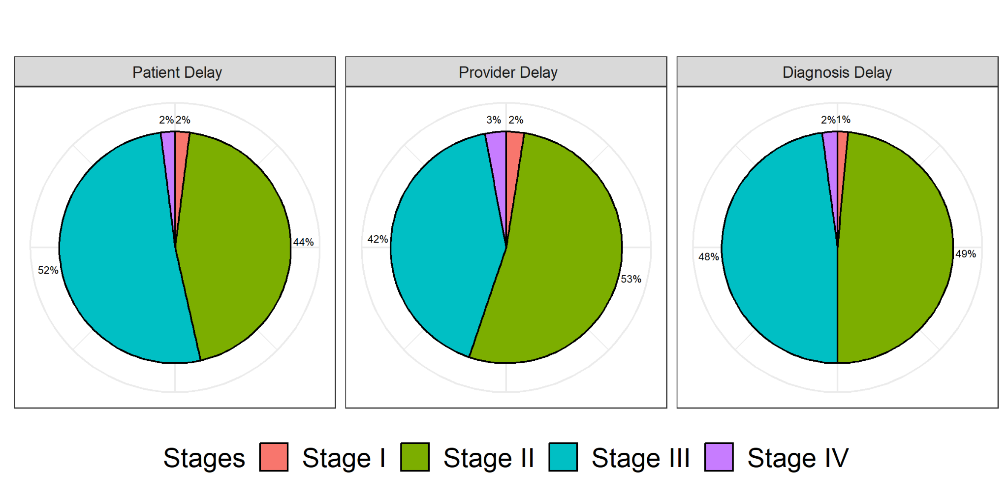

Figure 1: Breast cancer treatment delays at various stages

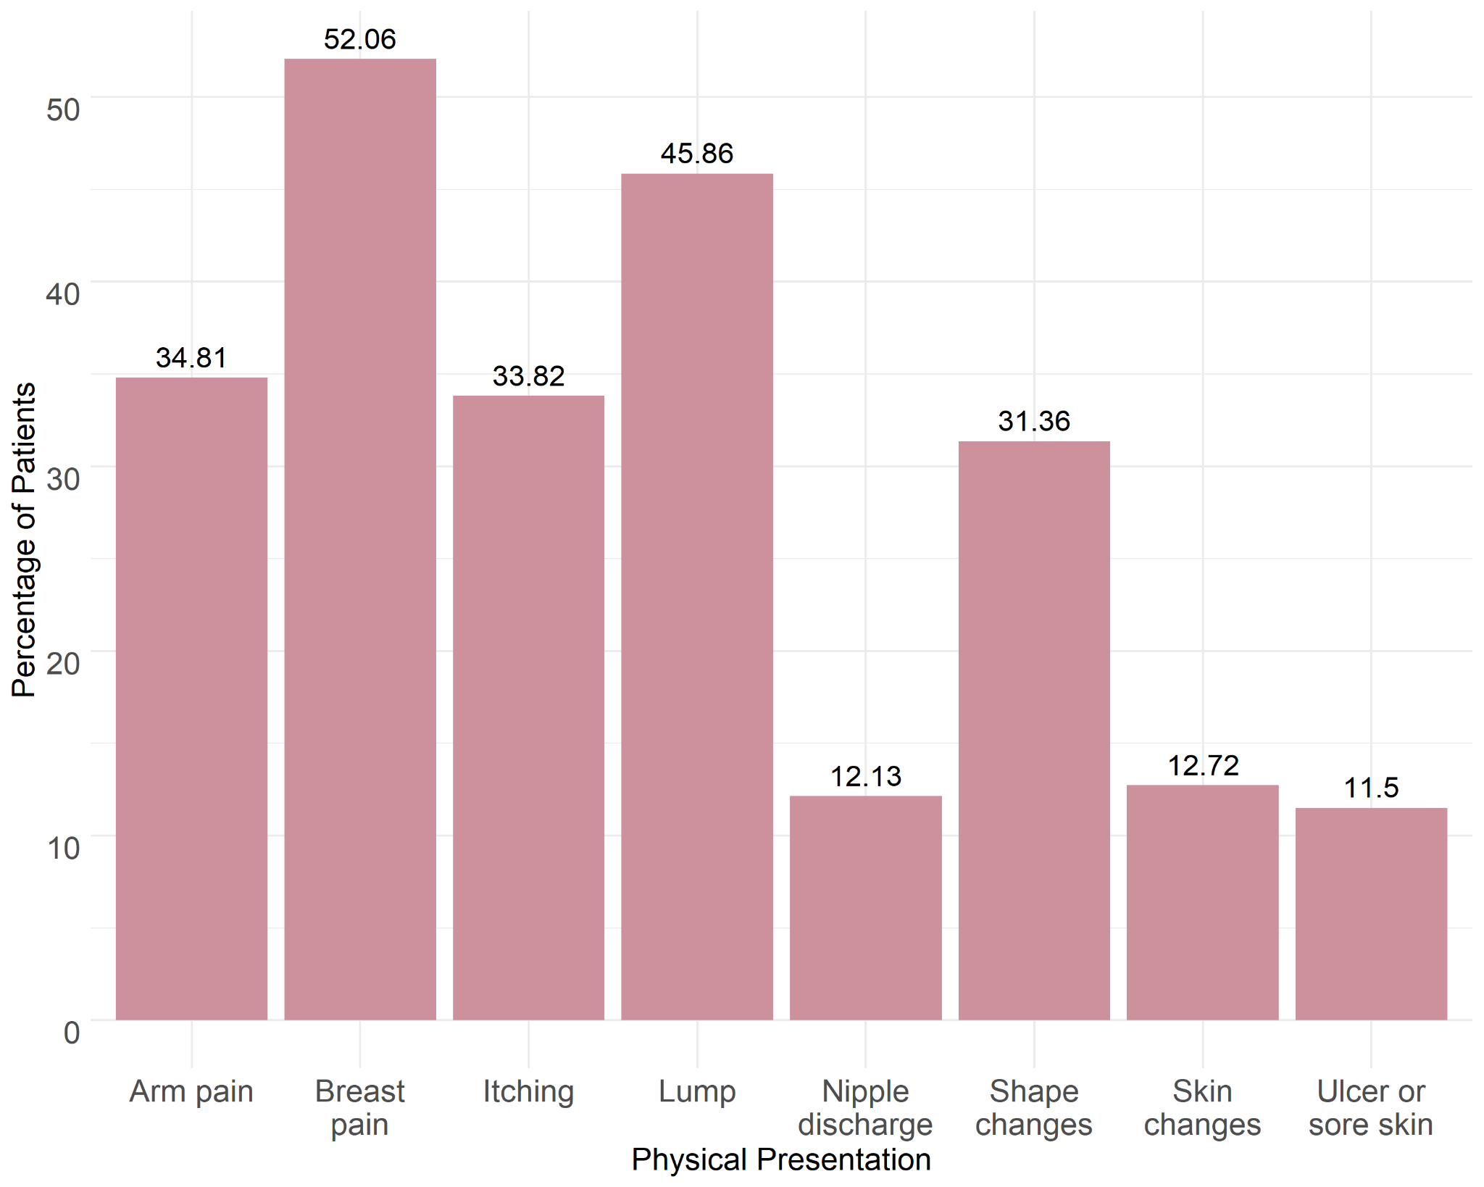

Figure 2: Physical presentations of the patients

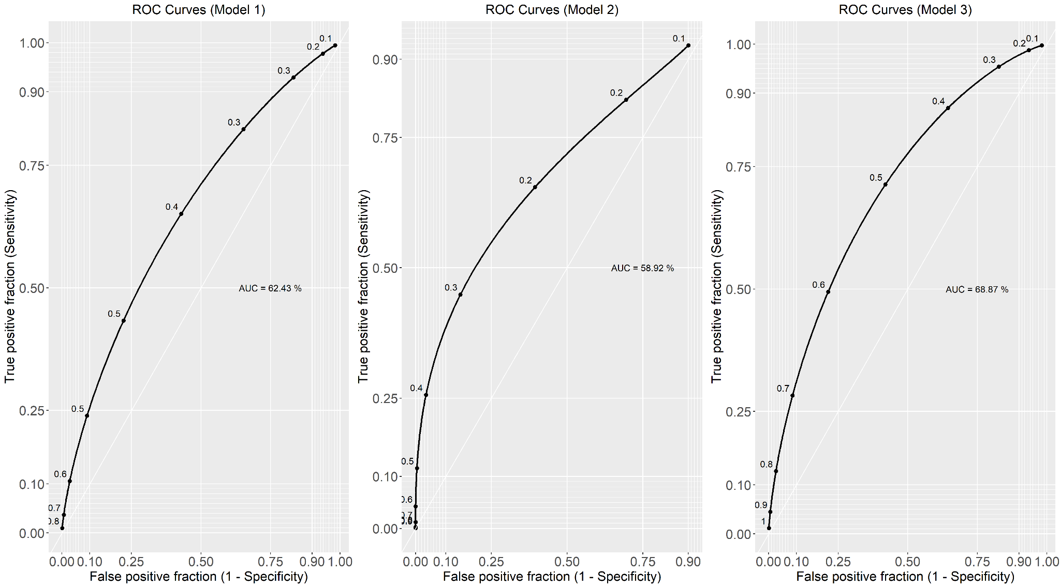

Figure 3: Model evaluations using the receiver operating characteristic curve (ROC curve) for adjusted model